# 

# List of Faculty

|  |  |  |  |  |  |
| --- | --- | --- | --- | --- | --- |
| **Sr.**  **No.** | **Faculty Name** | **Designation** | **Contact Number** | **E mail id** | **PHOTO** |
| 1 | Prof.  RamapatiMishra | Professor  (Director-IET) | 7351835666 | [directorietfzd@gmail.com](mailto:directorietfzd@gmail.com) |  |
| 2 | Dr. Brijesh Kumar Bhardwaj  (HOD MCA) | Associate Professor | 9450784497  9918999966 | [wwwbkb2012@gmail.com](mailto:wwwbkb2012@gmail.com) |  |
| 3 | Mr. Dileep Kumar | Assistant Professor | 9415716600 | [dileepk2000@yahoo.com](mailto:dileepk2000@yahoo.com) |  |
| 4 | Mr. Rama Nandan Tripathi | Assistant Professor | 9454885001 | [sonu.ramanandan@gmail.com](mailto:sonu.ramanandan@gmail.com) |  |

|  |  |  |  |  |  |
| --- | --- | --- | --- | --- | --- |
| 5 | Mr. Amit Kumar Bhasker | Assistant Professor | 9554654956 | [amit.bhasker@gmail.com](mailto:amit.bhasker@gmail.com) |  |
| 6 | Mr. Vivek Mishra | Assistant Professor | 8887548480 | [vivekmishra5122@gmail.com](mailto:vivekmishra5122@gmail.com) |  |
| 7 | Mr. Vivek Amlani | Assistant Professor | 9044273048 | [vivekamlani7@gmail.com](mailto:vivekamlani7@gmail.com) |  |
| 8 | Mr. Ram Naresh | Lab Assistant | 8756879123 | [ramnareshavadh2021@gmail.com](mailto:ramnareshavadh2021@gmail.com) |  |

**PHOTOS GALLERY**

**LAB OF PROGRAMMING LANGUAGES**

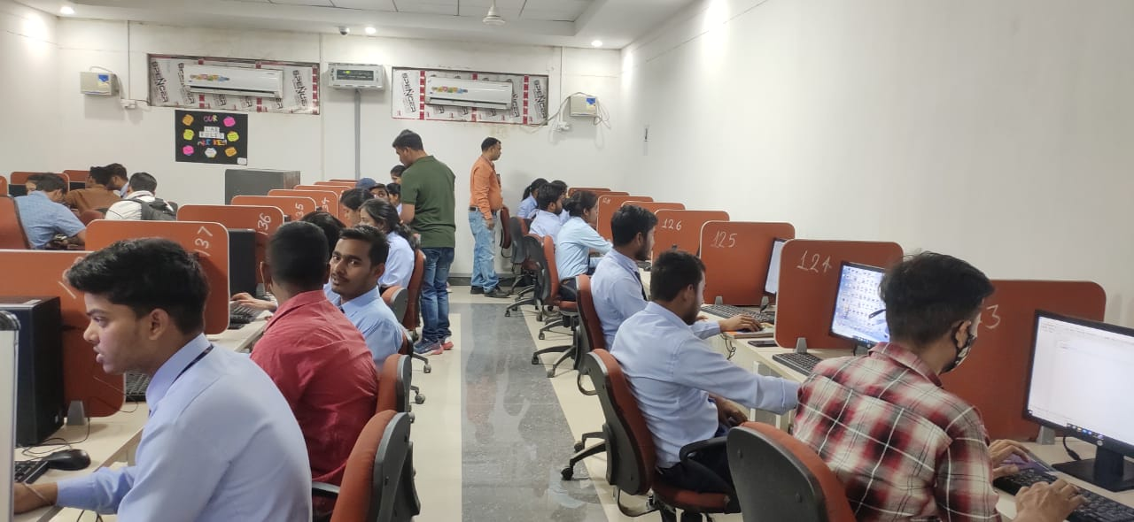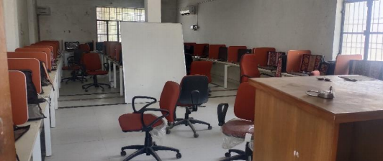

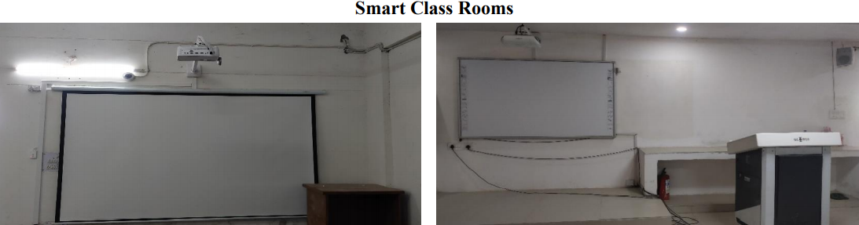

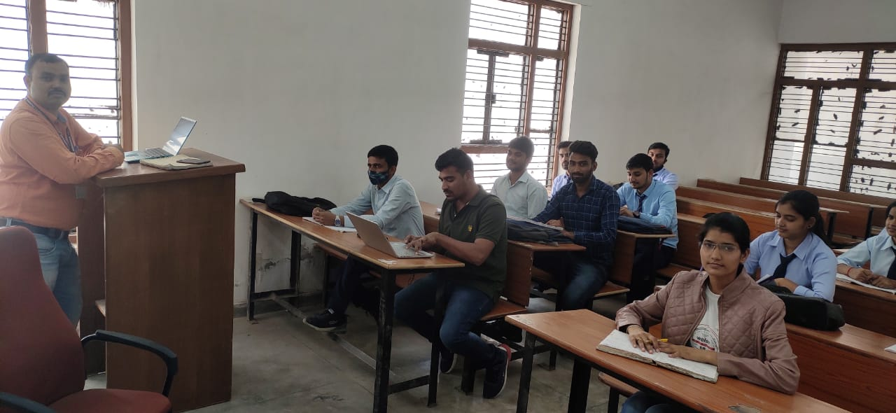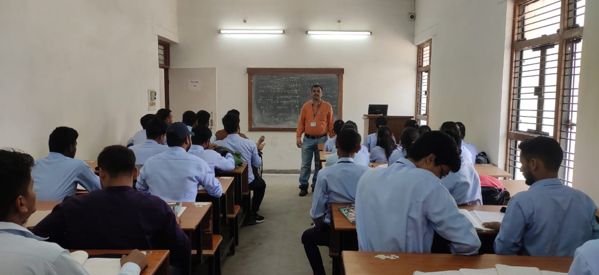

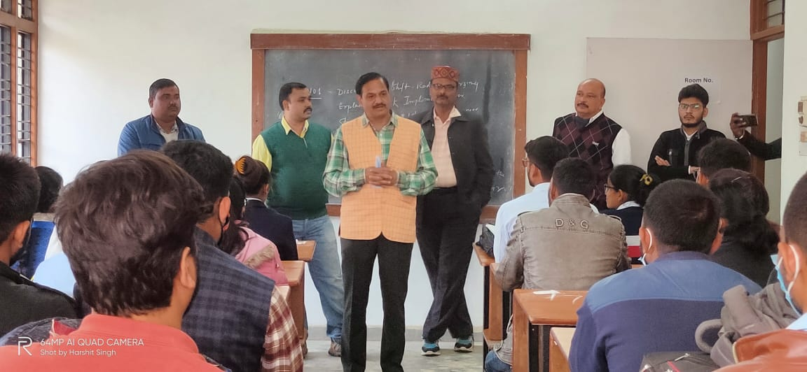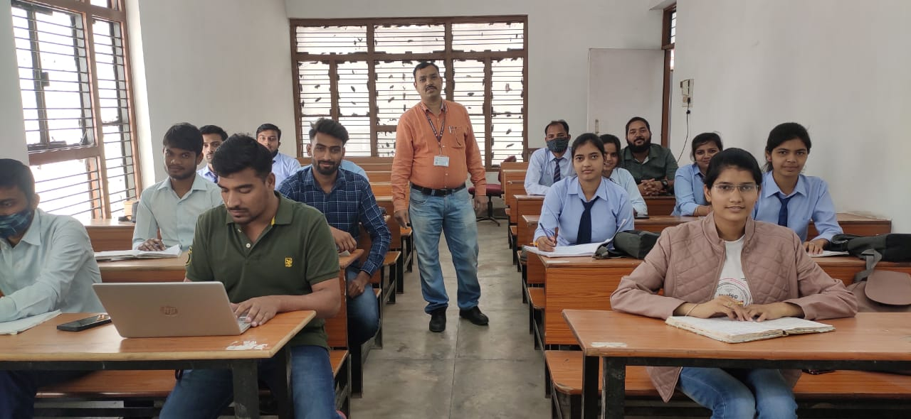

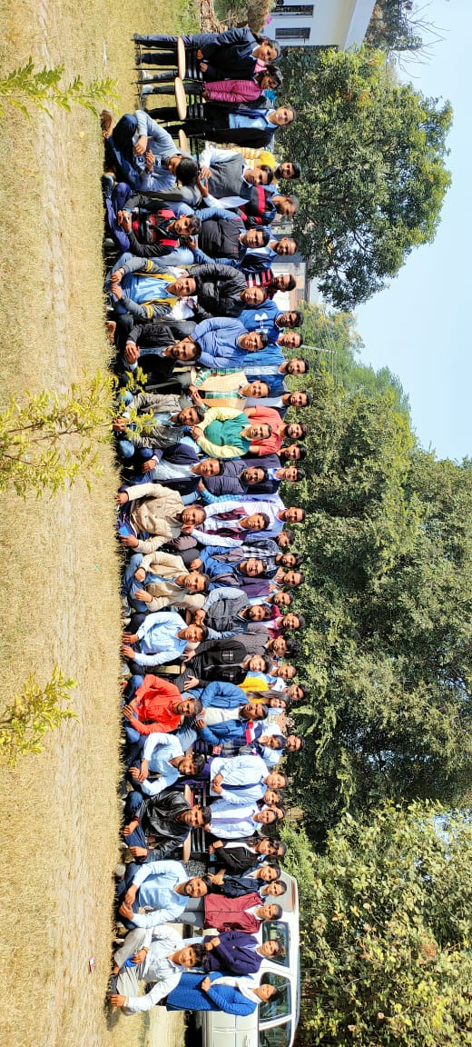

Farewell 2020

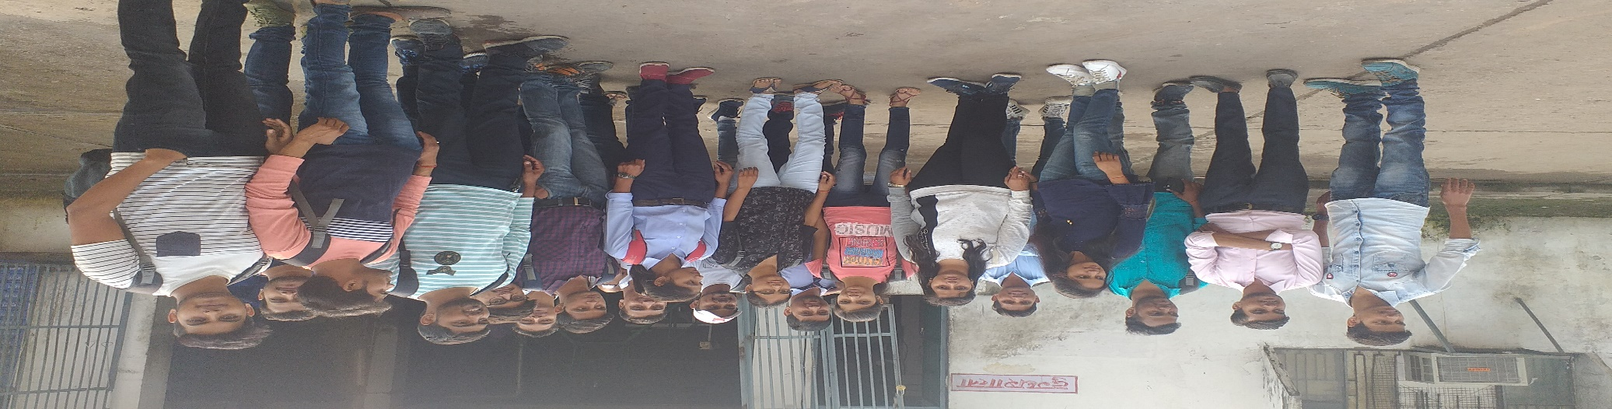

**Industrial Visit of 2020**

## **WORKSHOP ORGANIZED BY DEPARTMENT**

## **International webinar on “NEXT GENERATION COMPUTING SYSTEMS” On 17th May 2021 during COVID-19.**

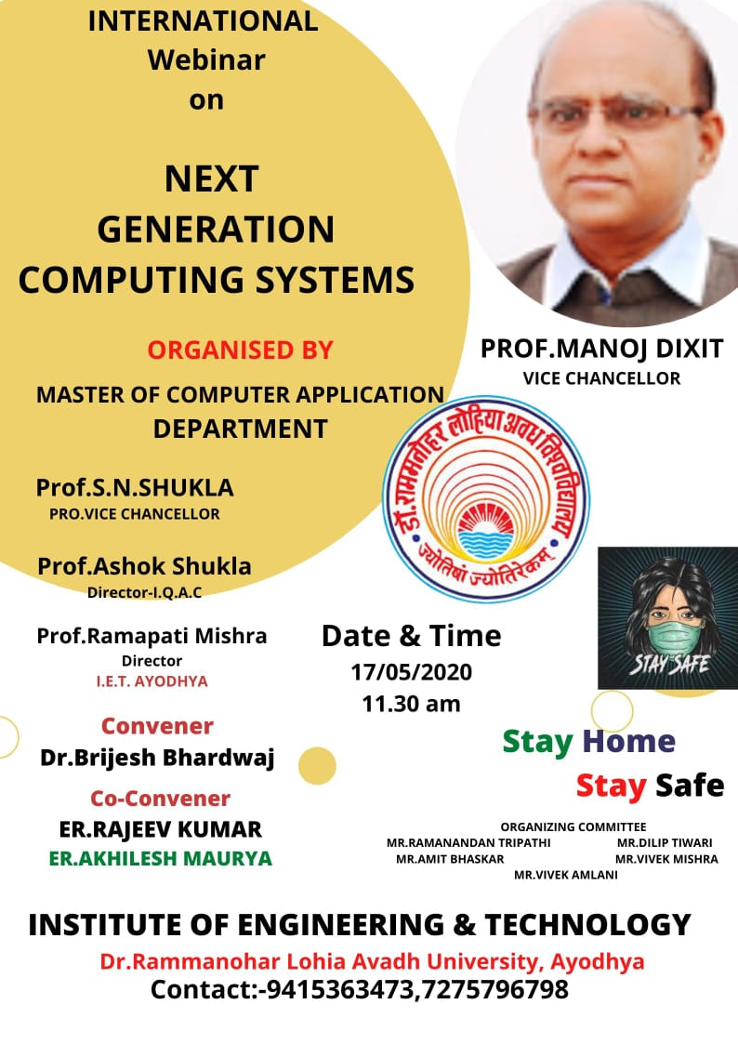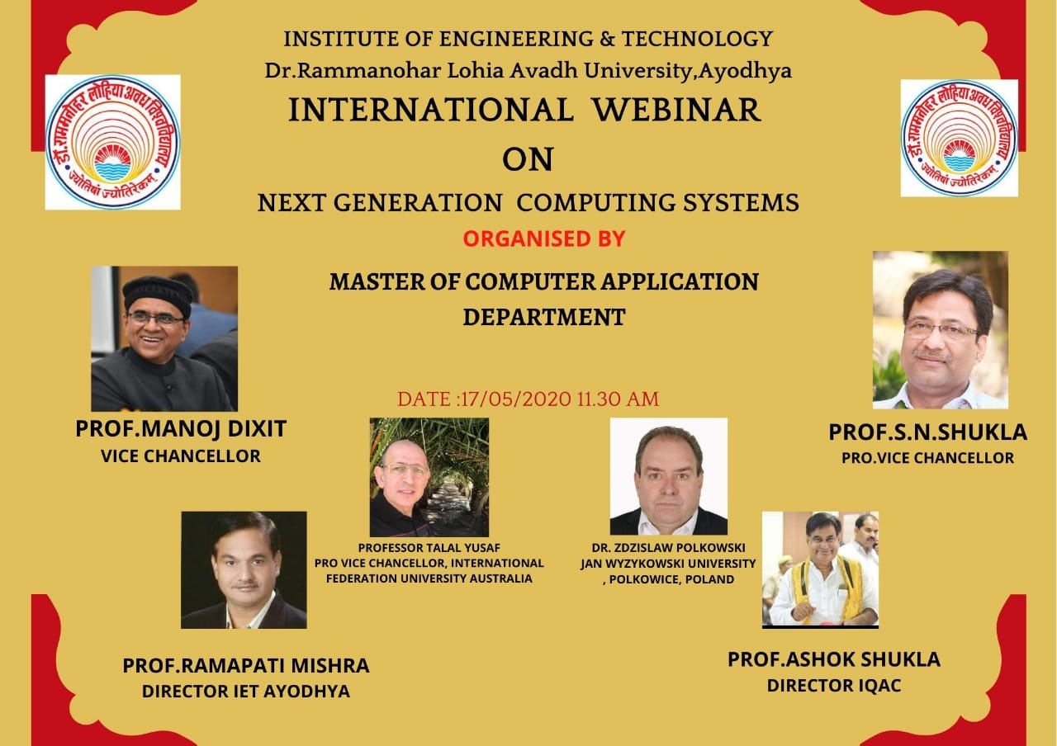

## **5 Days National Workshop on “JAVA FULL STACK” on 8th June -12th June 2020 during COVID-19.**

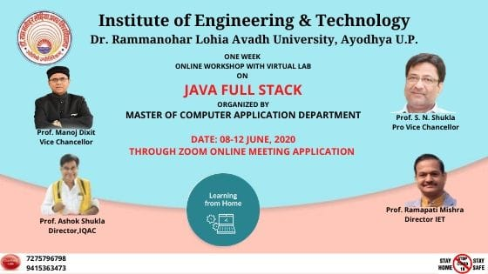

## **5 Days National Workshop on “PYTHON PROGRAMMING Expert talk on “INTERNET OF THINGS” on 07thJuly 2020**

## **WITH VIRTUAL LAB” on 20th June -24th June 2020. During COVID-19.**

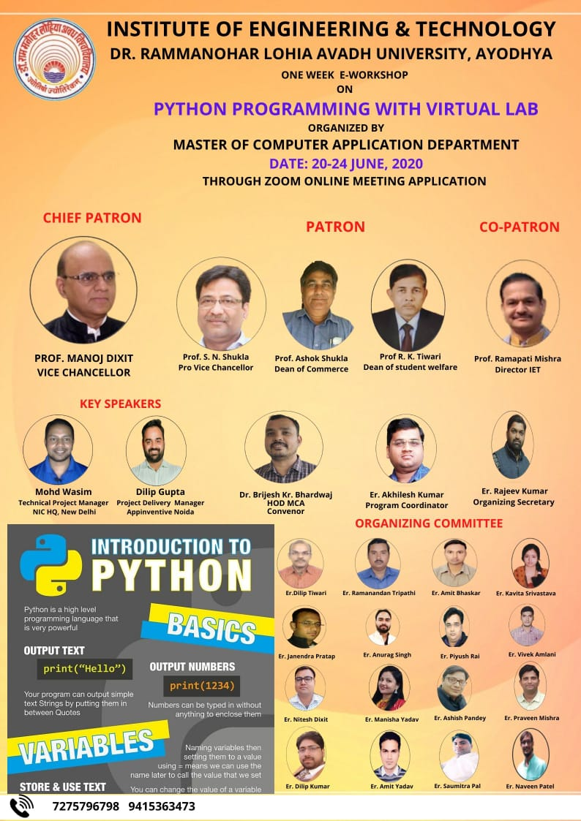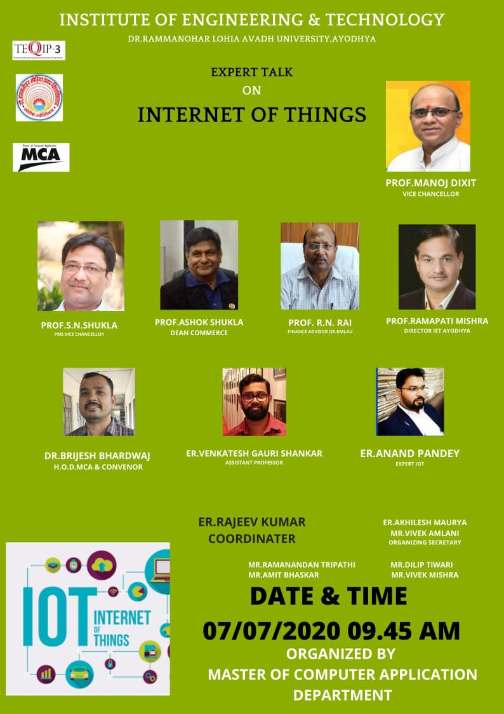

## **National Conference on “C214” on 28th July 2020 during COVID-19.**

